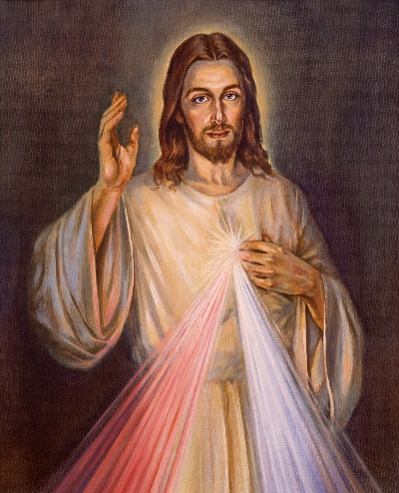
Divine Mercy
Catholic Church
A Jesuit Parish in St. John’s

Sunday Bulletin – Summer Edition
July 2nd: 13th Sunday in Ordinary Time
Mass Intentions  Week of July 2 – 8  Monday, July 3  Uriel & Larry Fagan; Denise Michaud; Isabelle Lauzon  Tuesday, July 4  John Kenny; Louis & Philippe Michaud (Jr.); Special Intention  Wednesday, July 5  Dolorosa & Nelson Ash; Souls in Purgatory; Walter Power  Thursday, July 6  Richard & Theresa Lawlor &  Deceased Family;  Tom & Mary Burke & Deceased Family; Peter Kelly  Friday, July 7  Joan & Howard Dyer; Philip Browne; Winnifred McCaul  Please Pray for the Recently Deceased: Mary Tracey | Parish Notes & Upcoming Events  Welcome to our Parish Bulletin – Summer Edition:  Summer is here! As we can anticipate a reduced pace in the parish, we will be producing a slimmed down version of our weekly bulletin through July and August. Blessings on everyone’s summer, may it be fun and relaxing and we pray for the safety of all those who will be travelling both near and far.  Fr. John Sullivan’s Summer Plans:  As many of you know, not only is Fr. John the Pastor of Divine Mercy Parish, he is also the Executive Director of Camp Ekon, the Jesuit summer camp for young people, located on Lake Joseph in Ontario’s Muskoka Lake Region. This summer, from mid July to mid August, Fr. John will head to Ekon to give them a helping hand through their busy season. While he’s away, he will stay in touch. You can reach Fr. John through email – john@ekon.ca or cell - 416-417-1513 at anytime.  Catholic Cemeteries Mass for the Faithful Departed  The annual Cemetery Mass at St. Francis of Assisi Cemetery, Outer Cove will take place on July 12 at 7pm. If the weather is inclement, the Mass will take place at Divine Mercy Parish (St. Francis Site).
Other News:

- June’s ‘Grand in Your Hand’ Winner: Pam Mackey, Ticket # 00046
- Basilica of St. John the Baptist Garden Party: Sunday, July 23rd 12:30pm, 200 Military Road (in case of inclement weather, the party will be moved to the Knights of Columbus building on St. Clare Ave.

Offertory Collection  Week of June 25  Offertory $ 4,556.00  Cemetery $ 40.00  Food Bank $ 380.00  Papal Charities $ 5.00  E-transfers can be made through dmparishnl@outlook.com Password: Church  (Please remember to include your full name and a message indicating what the E-transfer is for)  Thank you for your continuing generosity.  God Bless! |  | Daily Readings:  Week of  July 2-8  Sunday, July 2  2 Kings 4:8-11, 14-16a  Romans 6:3-4, 8-11  Matthew 10:37-42  Monday, July 3  Ephesians 2:19-22  John 20:24-29  Tuesday, July 4  Genesis 19:15-29  Matthew 8:23-27  Wednesday, July 5  Genesis 21:5, 8-20a  Matthew 8:28-34  Thursday, July 6  Genesis 22:1b-19  Matthew 9:1-8  Friday, July 7  Genesis  23:1-4, 19;24:1-8, 62-67  Matthew 9: 9-13  Saturday, July 8  Genesis 27:1-5, 15-29  Matthew 9:14-17 | Parish Schedule:  Sunday Mass:  Saturday  4:00pm St Paul’s Site  Sunday  9:00am St Francis Site  11:00am St Paul’s Site  Daily Mass:  Monday to Friday 9:30am  Daily Masses take place at our St. Paul’s Site  Parish Office Hours:  Monday – Thursday: 8:30am - 4:00pm  Friday: Office Closed through July and August
Saints Speak

He loves, He hopes, He waits.
Our Lord prefers to wait Himself for the sinner for years rather than keep us waiting an instant.

~ St. Maria Goretti
(Feast Day: July 6)

Divine Mercy Parish Contact Information:
Divine Mercy Parish, 340A Newfoundland Drive, St. John’s, NL A1A 3R9
709-726-9924 www.divinemercynl.com/ email: info@divinemercynl.com Facebook: Facebook.com/divinemercyparishnl
Fr. John Sullivan, S.J. Pastor Email: john@ekon.ca Telephone 416-417-1513

